Azure Documentation Assignment 1

1. Use the existing Vnet

Create a VNet which supports the IPv4 Address Space range from 192.168.0.0 to 192.168.255.255. The resource should follow the naming convention “YourName-SDETSHU-ResourceName”. The VNet should have 3 subnets. Each subnet must support the following number of addresses :

i.Subnet-A : 8 IP Addresses

ii.Subnet-B : 64 IP Addresses

iii.Subnet-C :256 IP Addresses

Tag your resource { Key: Value || Name:YourName-HU18-ResourceName }

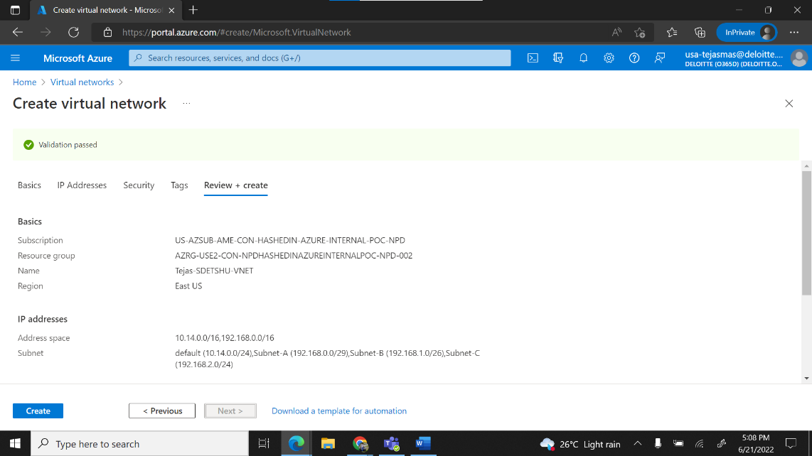

b. Create a Network Security Group. The resource should follow the naming convention “YourName-HU18-ResourceName”. Tag your resource { Key: Value || Name:YourName-HU18-ResourceName }. Associate Subnets from previously created VNet to the Network Security Group. Add the following rules :

i.SSH ( Port 22 ) with source as your IP Address

ii.HTTP ( Port 80 ) with source as your IP Address

c. Create a Virtual Machine. The resource should follow the naming convention “YourName-HU18-ResourceName-A”. It should have the following configurations :

i.Image : Ubuntu 18.04

ii.Size : Standard_B1s

iii.Authentication Type : Password

iv.Username : YourName

v.VM should be launched into the existing VNet.

vi.Pass a cloud-init script that installs and starts the service apache2.

vii.VM should not have a public IP attached to it.

Tag your resource { Key:Value || Name:YourName-HU18-ResourceName-A }

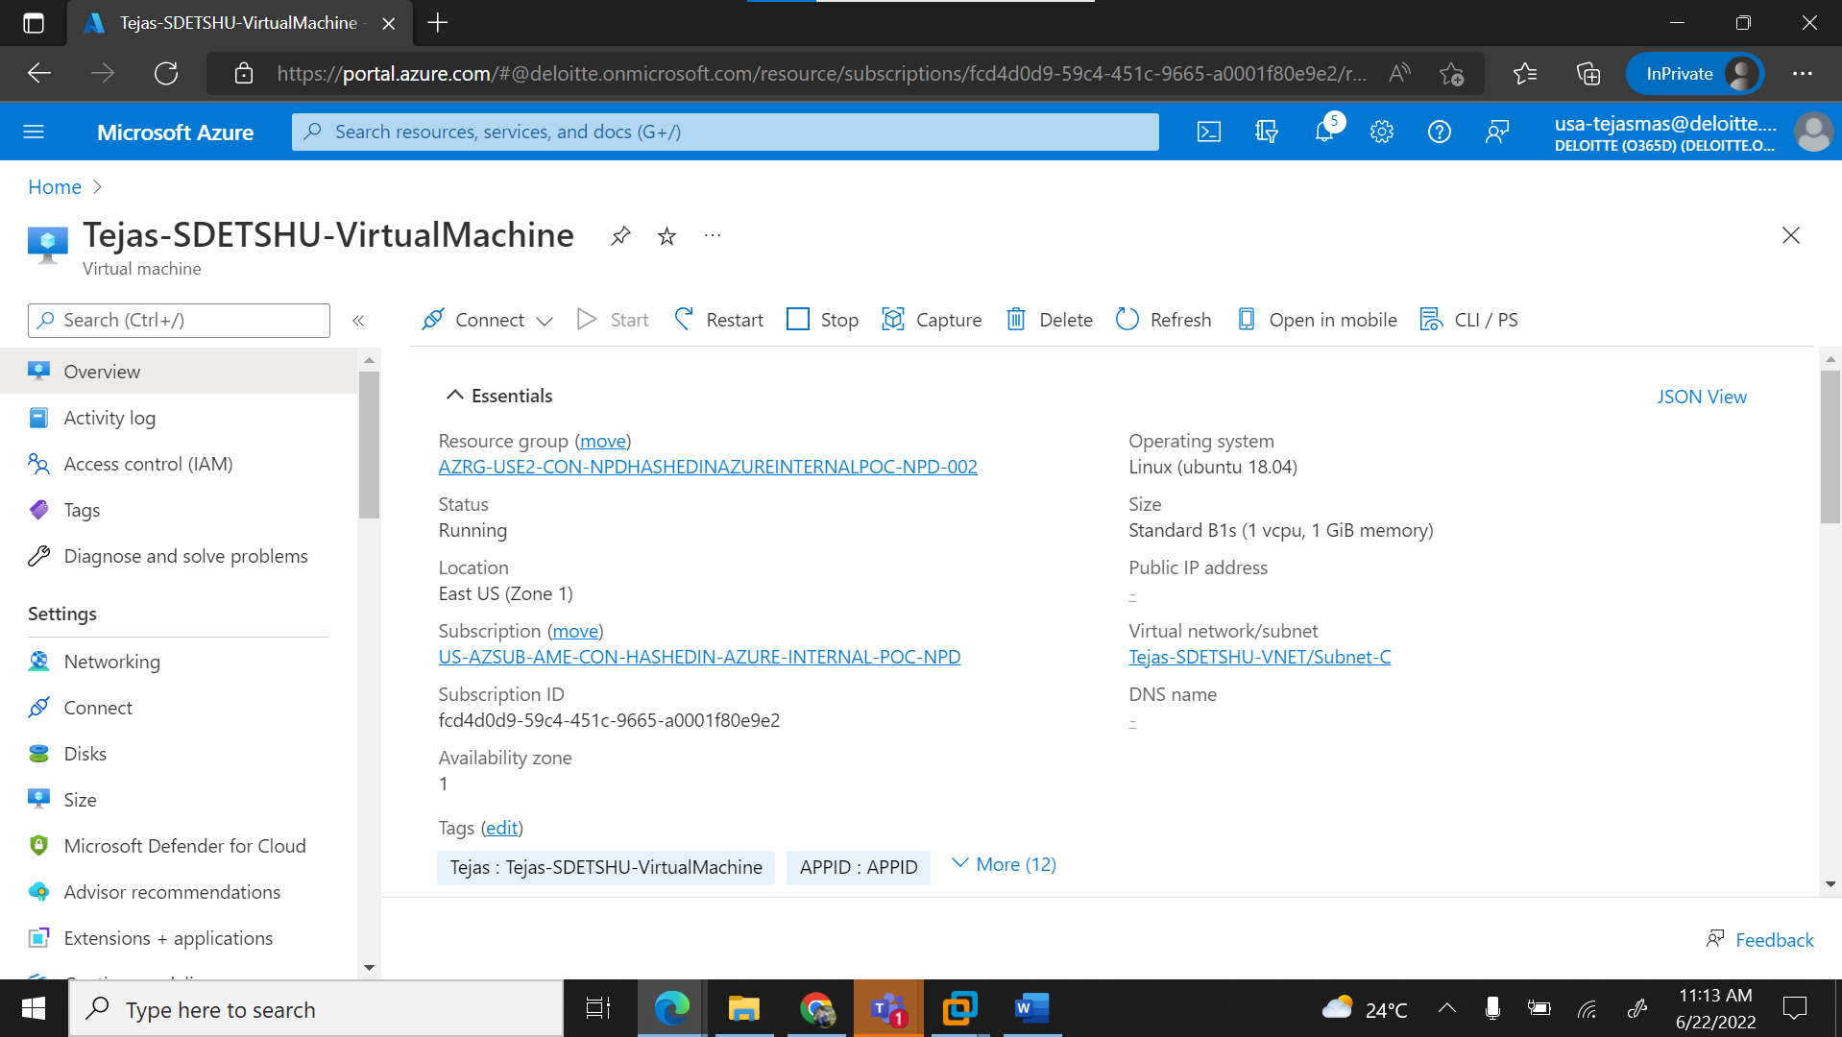

Cloud init script :

#cloud-config  
package_upgrade: true  
packages:  
- nginx  
- nodejs  
- npm  
- apache2  
runcmd:  
- service nginx restart  
- cd "/home/azureuser/myapp"  
- npm init  
- npm install express -y  
- nodejs index.js  
- systemctl start apache2

d. Create and attach a Managed Disk of 8 GB to previously created Virtual Machine.

Expectation: Attach screenshots for the following :

· Run the command “lsblk” before attaching the disk to the Virtual Machine

· Run the command “lsblk” after attaching the disk to the Virtual Machine

· Commands run in order to mount the disk

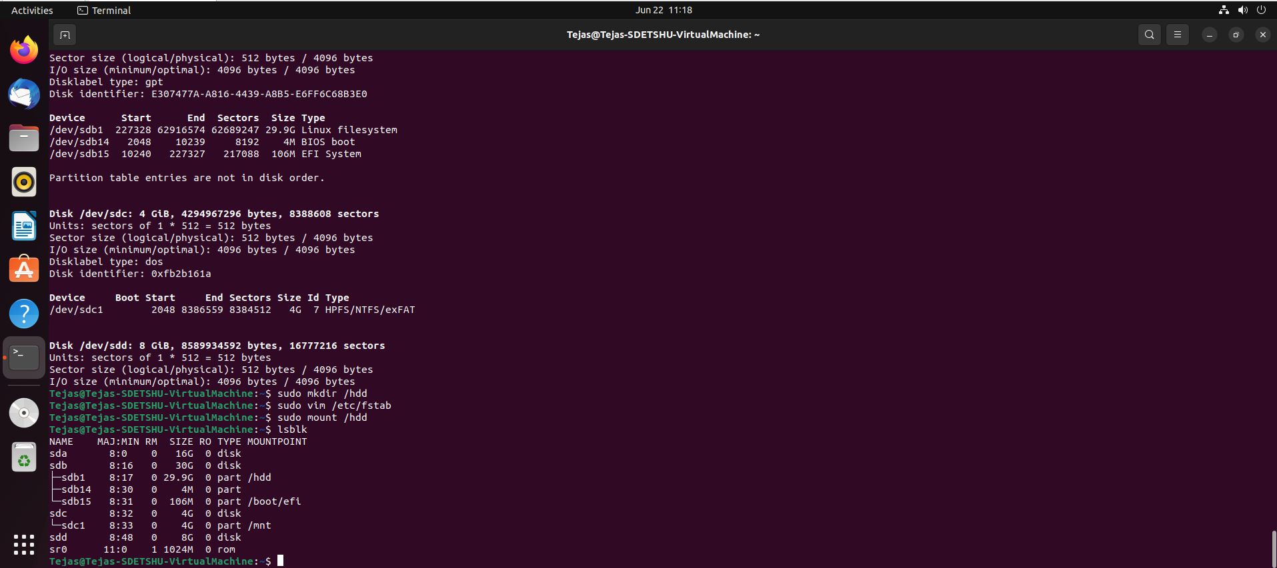

e. Create a Virtual Machine Scale Set. The resource should follow the naming convention “YourName-HU18-ResourceName-B”. It should have the following configurations :

i.Image : Ubuntu 18.04

ii.Size : Standard_B1s

iii.Authentication Type : SSH Public Key

iv.Username : YourName

v.VM should be launched into the previously created VNet.

vi.Enable boot diagnostics through a Custom Storage account with the naming convention “yournamehu18”.

vii.Initial Count : 3 , Minimum Count : 1 and Maximum Count 5

viii.Pass a cloud-init script that installs and starts the service nginx.

Tag your resource { Key:Value || Name:YourName-HU18-ResourceName-B }

Expectation: Attach screenshots for the following :

· Virtual Machine Scale Set overview

· Azure Monitor for the Virtual Machine Scale Set

· Storage Account with boot diagnostics

· Cloud-init file

Cloud init script :

#cloud-config  
package_upgrade: true  
packages:  
- nginx  
- nodejs  
- npm  
- apache2  
runcmd:  
- service nginx restart  
- cd "/home/azureuser/myapp"  
- npm init  
- npm install express -y  
- nodejs index.js  
- systemctl start nginx

f. Create a Private Load Balancer. The resource should follow the naming convention “YourName-HU18-ResourceName”. Tag your resource { Key:Value || Name:YourName-HU18-ResourceName}. It must serve traffic to the previously created Virtual Machine Scale Set on Port 80. Configure the Load Balancer accordingly.

Expectation: Attach screenshots for the following :

· Load Balancer Overview

· Backend Pools

· Load Balancer rules

· Outbound rules

· Health Probes

· Load Balancer IP

· Web page on Load Balancer I

